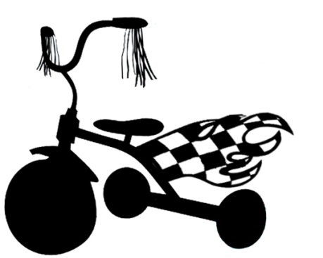
Kirk O’ The Valley School
Trike A Thon
Pledge Form
Hi Prospective Sponsor!
I will be participating in the Kirk O' The Valley Trike-A-Thon starting February 26th & 27th. All proceeds will go toward purchasing large wood toys for the playground. You can sponsor me for an amount per lap or you can give me a one time (flat fee) donation. After the Trike-A-Thon, I will tell you how many laps I completed and collect your contribution [please make checks payable to Kirk O' The Valley]. Thanks so much for helping us!

Name of Sponsor | Pledge per Lap  (e.g., $1) | One Time  Donation | Amount Collected

Child’s Name: ______________________________________

Name of Sponsor | Pledge per Lap  (e.g., $1) | One Time  Donation | Amount Collected

