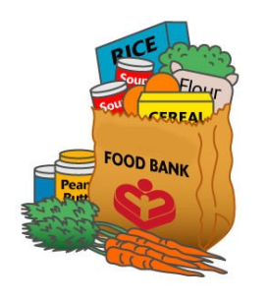
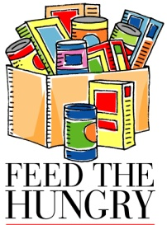
KIRK KIDS CARE
THANKSGIVING FOOD DRIVE FOR
WEST VALLEY FOOD PANTRY

The West Valley Food Pantry will be the recipient of our Thanksgiving Food Drive this year. They support 1500 families, representing 4500 people in the West Valley which is about
3 times the pre-recession level.

During this Holiday Season we are reminded to “share bread” with the hungry. Please deliver your donations to the Kirk from Nov.1 to Nov.16. If you don’t have time for shopping and would rather contribute money, it can be used to buy items that are in short supply. Please make checks out to the “West Valley Food Pantry”

Here are some items that are always needed, not in priority order. Other non-perishable items are welcomed as well:
- Canned tuna, meats, vegetables, fruits, spaghetti sauce
- Cereals
- Soup, dry or canned
- Beans, dry or canned
- Rice and pasta
- Jars of peanut butter, jam and jellies
- Powdered dry milk
- Baby food, formula, diapers, wipes
- Toilet paper, paper towels
- Toiletries and cosmetics
- Hand-operated can openers
Any and all donations will be greatly appreciated, however, if you wish and are a Costco-type shopper, boxes of similar items would be easy for the volunteers to sort. (ie. box of 8 cans of chili, etc.)

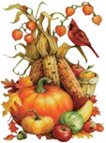
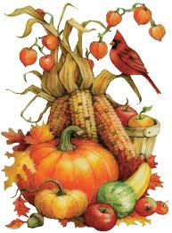
We gratefully accept all your donations in the provided bins by the school’s front gate. Monetary donations should be turned in to the school office.

Thank you!

