**Fourth Grade**

**Snack Cart**

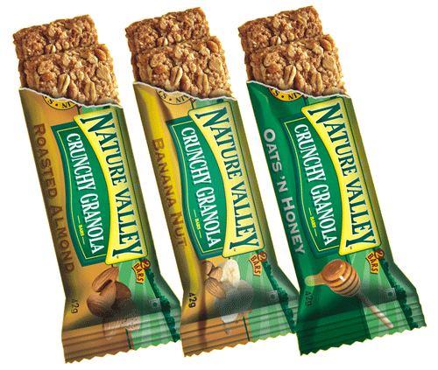

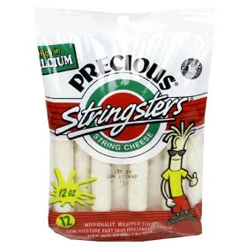

*Recess: Tuesday & Thursday*

*After school: Monday - Thursday*

All snacks cost $1

New healthier snack options include:

* string cheese
* applesauce pouches
* squeezable yogurt
* Pirate’s Booty
* granola bars
* Nutri Grain bars
* and more to come…



