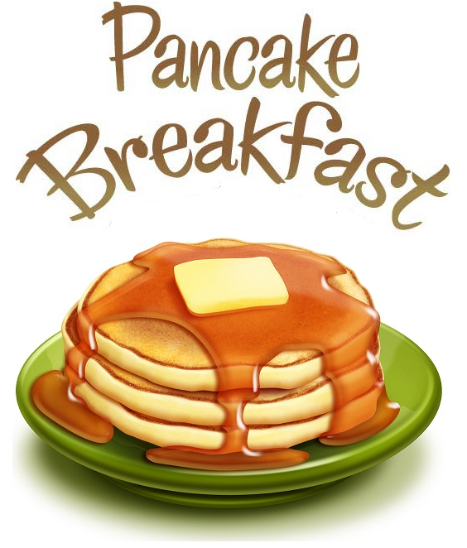

Hi Kirk Families,
Kirk’s annual “Pancake Breakfast and Raffle” is right around the corner! It will be held on Saturday, March 8, 2014. It is a wonderful way to spend a morning with all your friends, family and teachers. Bring your grandparents, aunts and uncles, and come enjoy a yummy pancake breakfast lovingly prepared by our wonderful Kirk volunteers! This fun-filled morning includes a basket raffle with many different kinds of prizes up for grabs.
DONATIONS:
We are soliciting donations to put up for raffle from local businesses and our own Kirk families. Here are some examples of needed donations:
CERTIFICATES restaurants, hotels, spas, movies, theatres, department stores…..
GIFTS toys, books, collectibles, sporting goods, stationery, home décor…
CASH to purchase items to be raffled
SERVICES home repair, hair and nail salons, landscaping, music lessons, accounting, housekeeping, painting…

No donation is too small—we can combine several small donations into one fantastic basket. Attached is a donation letter to give to your business or for you to solicit donations around town on behalf of Kirk. A great idea is to keep a copy handy at all times (e.g., in your purse, car, on your phone) so that you’re always ready when an opportunity arises! Also attached is a document that can serve as a temporary receipt to be given to the donor after you receive their contribution.
CLASS BASKETS:
Each class will choose a specific theme and have a chance to participate in creating a themed basket from their class that will be put up for the raffle. The room mom will work with the class to decide their theme. An email with details will be sent to the room moms shortly.
All donations must be received by February 21, 2014 so that we have time to wrap them and make them look beautiful. If you have any empty baskets we could use those also. Donations may be brought to the main office. If you have any donation questions please call Ajna Burke at (818) 268-2541.
Thank you for your participation and we look forward to seeing you at the pancake breakfast. Just follow the luscious smell of pancakes on March 8th!
Thank You!
The Pancake Breakfast Committee

